Bahria University,

Karachi Campus



LAB EXPERIMENT NO.

04

LIST OF TASKS

|  |  |
| --- | --- |
| TASK NO | OBJECTIVE |
| 1 | **Display Product Name and its Category Name where Category Name starts with B (Hint: Left join category and product, use wild card)** |
| 2 | **Display Titles and their quantity (Hint Pubs database, table title and sales, left join)** |
| 3 | **Use Right join to display Book Title and publisher Names (Hint pubs Database,**  **Table Title and Publisher) Write down the reason for any null values if coming in title column.** |
| 4 | **User Right join to display those publishers where title is null.** |
| 5 | **Use self-join to display Publishers name where country is same (Publisher id should be different) Sample example** |
| 6 | **Use cross join (Cartesian join) to Display Book Title and Publisher Name.** |
| 7 | **Use two full joins to Display Product Name, Category Name and Supplier Name (Hint: Below Example)** |
| 8 | **Use full join to display the name of Supplier for the product starting with letter C (Hint: Northwind)** |
| 9 | **Get shipper’s Company Name for an order using inner join. (Display only orderID from orders and comapnayName from Customers table)** |
| 10 | **Count no of Products’s against each suppliers name. list only those products whose count is greater than 3** |
| 11 | **Display Region ID, Region Description, Territories Description and (inner join with table Territories and Region)** |
| 12 | **Display Company Name and Total orders placed by the company (Table: orders, customer, use inner join, group by)** |

Submitted On

04-04-202

**Task No. 1: Display Product Name and its Category Name where Category Name starts with B (Hint: Left join category and product, use wild card)**

**Solution:** select products.productname,categories.categoryname from products right join categories on products.categoryid=categories.categoryid where categoryname like 'B%'

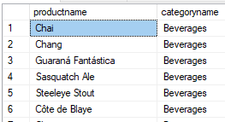 **OUTPUT**:

**Task No. 2: Display Titles and their quantity (Hint Pubs database, table title and sales, left join)**

**Solution:** select titles.title,sum(sales.qty) as qty from titles left join sales on titles.title_id=sales.title_id group by titles.title

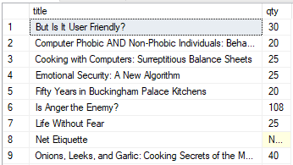**OUTPUT**:

**Task No. 3:** Use Right join to display Book Title and publisher Names (Hint pubs Database,

Table Title and Publisher) Write down the reason for any null values if coming in title column.

**Solution:** select titles.title,publishers.pub_name from titles right join publishers on titles.pub_id=publishers.pub_id

**OUTPUT**:

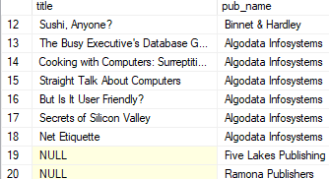

**Task No. 4: User Right join to display those publishers where title is null.**

**Solution:** select publishers.pub_name,titles.title from titles right join publishers on titles.pub_id=publishers.pub_id where titles.title is null

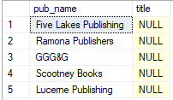 **OUTPUT**:

**Task No. 5:** Use self-join to display Publishers name where country is same (Publisher id should be different) Sample example

**Solution:** SELECT A.pub_name AS PublisherName1, B.pub_name AS PublisherName2, A.country FROM publishers A, publishers B where A.country=B.country and A.pub_id<>B.pub_id

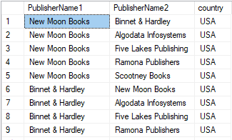 **OUTPUT**:

**Task No. 6: Use cross join (Cartesian join) to Display Book Title and Publisher Name.**

**Solution:** select publishers.pub_name,titles.title from titles cross join publishers

**OUTPUT**:

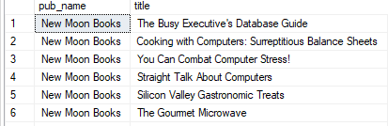

**Task No. 7: Use two full joins to Display Product Name, Category Name and Supplier Name (Hint: Below Example)**

**Solution:** select Products.ProductName,Suppliers.ContactName,Categories.CategoryName from products full join suppliers on Products.SupplierID=Suppliers.SupplierID full join Categories on Products.CategoryID =Categories.CategoryID;

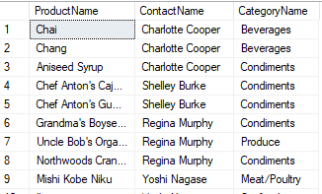 **OUTPUT**:

**Task No. 8: Use full join to display the name of Supplier for the product starting with letter C (Hint: Northwind)**

**Solution:** select suppliers.contactname,products.productname from suppliers full outer join products on suppliers.supplierid=products.supplierid

where products.productname like 'C%'

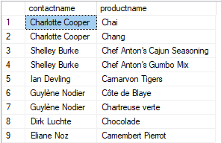**OUTPUT**:

**Task No 9: Get shipper’s Company Name for an order using inner join. (Display only orderID from orders and comapnayName from Customers table)**

**Solution:** select orders.orderid, shippers.companyname, orders.orderdate from orders inner join shippers on orders.shipvia = shippers.shipperid

**Output:**

**Task 10: Count no of Products’s against each suppliers name. list only those products whose count is greater than 3**

**Solution:** select count(products.productid) as TP, suppliers.contactname from suppliers inner join products on suppliers.supplierid = products.supplierid group by suppliers.contactname having count (products.productid)>3

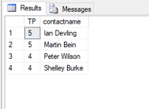**Output:**

**Task 11: Display Region ID, Region Description, Territories Description and (inner join with table Territories and Region)**

**Solution:** select region.regionid, region.regiondescription, territories.territorydescription from region inner join territories on region.regionid = territories.regionid

**Output:**

**Task 12: Display Company Name and Total orders placed by the company (Table: orders, customer, use inner join, group by)**

**Solution:** select customers.companyname, count (orders.orderid)as TotalOrder from orders inner join customers on orders.customerid = customers.customerid group by customers.companyname

**Output:**

